Nitesh Joshi
E23CSEU1970

!wgettar - http://efrosgansxvf edg s2shoes.tar.gz.eecs.berkeley.edu/pix2pix/datasets/edges2shoes
!tar -xvf edges2shoes.tar.gz edges2shoes/train/47281_AB.jpg edges2shoes/train/47282_AB.jpg edges2shoes/train/47283_AB.jpg edges2shoes/train/47284_AB.jpg edges2shoes/train/47285_AB.jpg edges2shoes/train/47286_AB.jpg edges2shoes/train/47287_AB.jpg edges2shoes/train/47288_AB.jpg edges2shoes/train/47289_AB.jpg edges2shoes/train/4728_AB.jpg edges2shoes/train/47290_AB.jpg edges2shoes/train/47291_AB.jpg edges2shoes/train/47292_AB.jpg edges2shoes/train/47293_AB.jpg edges2shoes/train/47294_AB.jpg edges2shoes/train/48843_AB.jpg edges2shoes/train/48844_AB.jpg edges2shoes/train/48845_AB.jpg edges2shoes/train/48846_AB.jpg edges2shoes/train/48847_AB.jpg edges2shoes/train/48848_AB.jpg edges2shoes/train/48849_AB.jpg edges2shoes/train/4884_AB.jpg edges2shoes/train/48850_AB.jpg edges2shoes/train/48851_AB.jpg edges2shoes/train/48852_AB.jpg edges2shoes/train/48853_AB.jpg edges2shoes/train/48854_AB.jpg edges2shoes/train/48855_AB.jpg edges2shoes/train/48856_AB.jpg edges2shoes/train/48857_AB.jpg edges2shoes/train/48858_AB.jpg edges2shoes/train/48859_AB.jpg edges2shoes/train/480_AB.jpg edges2shoes/train/48100_AB.jpg edges2shoes/train/48101_AB.jpg edges2shoes/train/48102_AB.jpg edges2shoes/train/48103_AB.jpg edges2shoes/train/48104_AB.jpg edges2shoes/train/48105_AB.jpg edges2shoes/train/48106_AB.jpg edges2shoes/train/48107_AB.jpg edges2shoes/train/48108_AB.jpg edges2shoes/train/48109_AB.jpg edges2shoes/train/4810_AB.jpg edges2shoes/train/48110_AB.jpg edges2shoes/train/48111_AB.jpg edges2shoes/train/48112_AB.jpg edges2shoes/train/48113_AB.jpg edges2shoes/train/48114_AB.jpg edges2shoes/train/48115_AB.jpg edges2shoes/train/48116_AB.jpg edges2shoes/train/48117_AB.jpg edges2shoes/train/48118_AB.jpg edges2shoes/train/48119_AB.jpg edges2shoes/train/49521_AB.jpg edges2shoes/train/49522_AB.jpg edges2shoes/train/49523_AB.jpg edges2shoes/train/49524_AB.jpg edges2shoes/train/49525_AB.jpg
import os from PIL import Image
os.makedirs("dataset/train/input", exist_ok=True) os.makedirs("dataset/train/target", exist_ok=True) source_folder = "edges2shoes/train"
for i, img_name in enumerate(os.listdir(source_folder)):
if i > 1000: # LIMIT for faster training (remove this line for
break
img = Image.open(os.path.join(source_folder, img_name))
w, h = img.size
input_img = img.crop((0, 0, w//2, h))
target_img = img.crop((w//2, 0, w, h))
input_img.save(f"dataset/train/input/{img_name}")
target_img.save(f"dataset/train/target/{img_name}") print("Dataset Prepared Successfully!") Dataset Prepared Successfully!
import torch import torch.nn as nn import torch.optim as optim from torchvision import transforms from torch.utils.data import Dataset, DataLoader
from PIL import Image
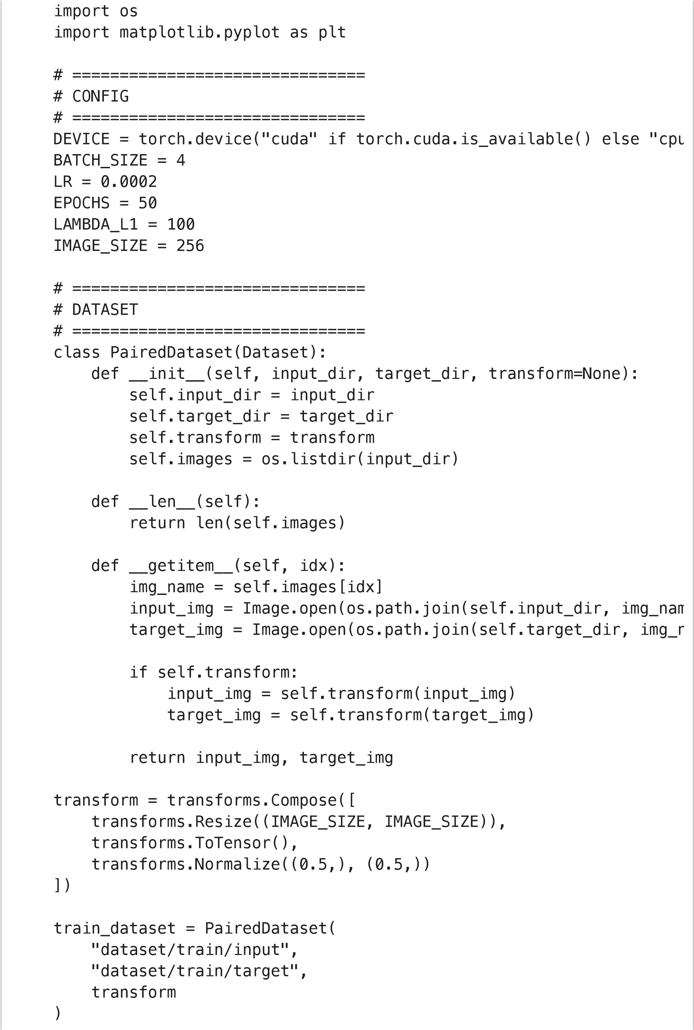
train_loader = DataLoader(train_dataset, batch_size=BATCH_SIZE, shu
# ===============================
# U-NET GENERATOR
# =============================== class Down(nn.Module):
def __init__(self, in_c, out_c, normalize=True):
super().__init__()
layers = [nn.Conv2d(in_c, out_c, 4, 2, 1, bias=False)]
if normalize:
layers.append(nn.BatchNorm2d(out_c))
layers.append(nn.LeakyReLU(0.2)) self.model = nn.Sequential(*layers)
def forward(self, x):
return self.model(x)
class Up(nn.Module):
def __init__(self, in_c, out_c):
super().__init__()
self.model = nn.Sequential( nn.ConvTranspose2d(in_c, out_c, 4, 2, 1, bias=False),
nn.BatchNorm2d(out_c),
nn.ReLU(True)
)
def forward(self, x, skip):
x = self.model(x)
return torch.cat([x, skip], 1)
class Generator(nn.Module):
def __init__(self):
super().__init__()
self.d1 = Down(3, 64, False)
self.d2 = Down(64, 128)
self.d3 = Down(128, 256)
self.d4 = Down(256, 512)
self.u1 = Up(512, 256)
self.u2 = Up(512, 128)
self.u3 = Up(256, 64)
self.final = nn.Sequential( nn.ConvTranspose2d(128, 3, 4, 2, 1),
nn.Tanh()
)
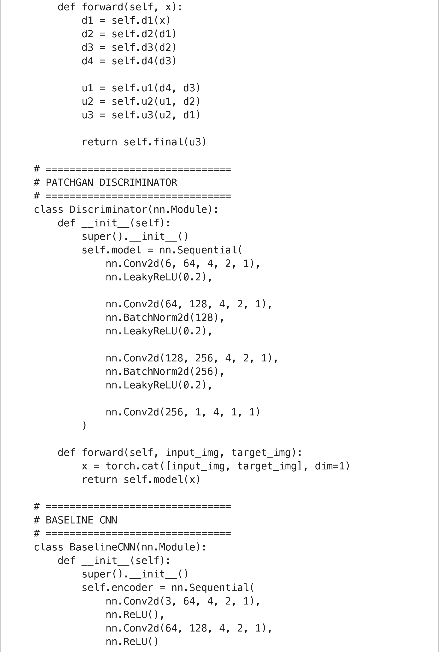
)
self.decoder = nn.Sequential( nn.ConvTranspose2d(128, 64, 4, 2, 1),
nn.ReLU(), nn.ConvTranspose2d(64, 3, 4, 2, 1),
nn.Tanh()
)
def forward(self, x):
return self.decoder(self.encoder(x))
# ===============================
# INITIALIZE MODELS
# =============================== generator = Generator().to(DEVICE) discriminator = Discriminator().to(DEVICE) baseline = BaselineCNN().to(DEVICE)
opt_G = optim.Adam(generator.parameters(), lr=LR, betas=(0.5, 0.999 opt_D = optim.Adam(discriminator.parameters(), lr=LR, betas=(0.5, 0 opt_base = optim.Adam(baseline.parameters(), lr=LR)
criterion_GAN = nn.MSELoss() criterion_L1 = nn.L1Loss()
# ===============================
# TRAINING LOOP
# =============================== for epoch in range(EPOCHS):
for input_img, target_img in train_loader:
input_img = input_img.to(DEVICE)
target_img = target_img.to(DEVICE)
# ---------------------
# Train Discriminator
# ---------------------
opt_D.zero_grad()
fake_img = generator(input_img)
real_pred = discriminator(input_img, target_img)
fake_pred = discriminator(input_img, fake_img.detach())
loss_real = criterion_GAN(real_pred, torch.ones_like(real_p
loss_fake = criterion_GAN(fake_pred, torch.zeros_like(fake_ loss_D = (loss_real + loss_fake) * 0.5
loss_D.backward()
opt_D.step()
# ---------------------
# Train Generator
# ---------------------
opt_G.zero_grad()
fake_pred = discriminator(input_img, fake_img)
loss_GAN = criterion_GAN(fake_pred, torch.ones_like(fake_pr
loss_L1 = criterion_L1(fake_img, target_img) * LAMBDA_L1 loss_G = loss_GAN + loss_L1
loss_G.backward()
opt_G.step()
# ---------------------
# Train Baseline CNN
# ---------------------
opt_base.zero_grad()
base_out = baseline(input_img)
loss_base = criterion_L1(base_out, target_img)
loss_base.backward()
opt_base.step() print(f"Epoch [{epoch+1}/{EPOCHS}] | D: {loss_D.item():.4f} | G
# ===============================
# SAVE MODELS
# ===============================
torch.save(generator.state_dict(), "generator.pth") torch.save(discriminator.state_dict(), "discriminator.pth") torch.save(baseline.state_dict(), "baseline.pth") print("Training Complete!")
Epoch [1/50] | D: 0.1326 | G: 23.8385 | Base: 0.3046
Epoch [2/50] | D: 0.1740 | G: 23.6484 | Base: 0.4318
Epoch [3/50] | D: 0.2696 | G: 20.5333 | Base: 0.4286
Epoch [4/50] | D: 0.2144 | G: 16.2506 | Base: 0.5296
Epoch [5/50] | D: 0.0709 | G: 12.5423 | Base: 0.2945
Epoch [6/50] | D: 0.0793 | G: 23.4040 | Base: 0.2501
Epoch [7/50] | D: 0.0875 | G: 28.0215 | Base: 0.2757
Epoch [8/50] | D: 0.1936 | G: 12.7036 | Base: 0.3238
Epoch [9/50] | D: 0.3700 | G: 17.4188 | Base: 0.4683
Epoch [10/50] | D: 0.0661 | G: 29.0178 | Base: 0.3511
Epoch [11/50] | D: 0.1447 | G: 12.4998 | Base: 0.5132
Epoch [12/50] | D: 0.0819 | G: 13.6663 | Base: 0.3779
Epoch [13/50] | D: 0.0919 | G: 14.3000 | Base: 0.3940
Epoch [14/50] | D: 0.0555 | G: 12.9992 | Base: 0.4653

Epoch [15/50] | D: 0.3715 | G: 13.9545 | Base: 0.4313
Epoch [16/50] | D: 0.2921 | G: 8.2361 | Base: 0.1598
Epoch [17/50] | D: 0.1919 | G: 13.8081 | Base: 0.3025
Epoch [18/50] | D: 0.1326 | G: 13.0462 | Base: 0.6527
Epoch [19/50] | D: 0.2411 | G: 5.2493 | Base: 0.2288
Epoch [20/50] | D: 0.0493 | G: 9.2747 | Base: 0.3478
Epoch [21/50] | D: 0.2254 | G: 11.3301 | Base: 0.6343
Epoch [22/50] | D: 0.2876 | G: 15.3689 | Base: 0.3124
Epoch [23/50] | D: 0.1354 | G: 6.4848 | Base: 0.2591
Epoch [24/50] | D: 0.0393 | G: 5.6221 | Base: 0.4948
Epoch [25/50] | D: 0.1374 | G: 13.6044 | Base: 0.2861
Epoch [26/50] | D: 0.1897 | G: 3.9318 | Base: 0.2597
Epoch [27/50] | D: 0.1872 | G: 9.1262 | Base: 0.5169
Epoch [28/50] | D: 0.1604 | G: 9.2063 | Base: 0.4226
Epoch [29/50] | D: 0.2314 | G: 7.1753 | Base: 0.2388
Epoch [30/50] | D: 0.0972 | G: 8.4770 | Base: 0.4747
Epoch [31/50] | D: 0.1922 | G: 6.6966 | Base: 0.0946
Epoch [32/50] | D: 0.2732 | G: 6.1737 | Base: 0.2416
Epoch [33/50] | D: 0.1113 | G: 6.8787 | Base: 0.1766
Epoch [34/50] | D: 0.2740 | G: 3.8584 | Base: 0.5602
Epoch [35/50] | D: 0.1239 | G: 16.1348 | Base: 0.4111
Epoch [36/50] | D: 0.2689 | G: 9.2613 | Base: 0.4196
Epoch [37/50] | D: 0.1940 | G: 6.5232 | Base: 0.6022
Epoch [38/50] | D: 0.0922 | G: 5.6428 | Base: 0.3318
Epoch [39/50] | D: 0.0779 | G: 7.7947 | Base: 0.3940
Epoch [40/50] | D: 0.1708 | G: 5.6364 | Base: 0.5595
Epoch [41/50] | D: 0.1839 | G: 7.6923 | Base: 0.3897
Epoch [42/50] | D: 0.2386 | G: 12.7532 | Base: 0.3503
Epoch [43/50] | D: 0.1116 | G: 4.4683 | Base: 0.3012
Epoch [44/50] | D: 0.3022 | G: 4.1060 | Base: 0.1722
Epoch [45/50] | D: 0.3117 | G: 4.3732 | Base: 0.2126
Epoch [46/50] | D: 0.2686 | G: 7.9298 | Base: 0.3121
Epoch [47/50] | D: 0.1358 | G: 7.9810 | Base: 0.3704
Epoch [48/50] | D: 0.1213 | G: 9.1755 | Base: 0.2516
Epoch [49/50] | D: 0.2128 | G: 3.6445 | Base: 0.3876
Epoch [50/50] | D: 0.2295 | G: 5.8088 | Base: 0.3301
Training Complete!
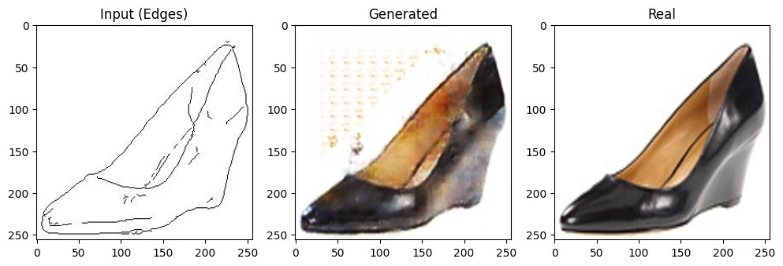
import

matplotlib.pyplot

as

plt
generator.
eval
()
input_img
,

target_img

=

next
(
iter
(
train_loader
))
input_img

=

input_img.to
(
DEVICE
)
with

torch.no_grad
():

fake_img

=

generator
(
input_img
)
plt.figure
(
figsize=
(
12
,
4
))
plt.subplot
(
1
,
3
,
1
)
plt.title
(
"Input

(
Edges)"
)
plt.imshow
(
input_img
[
0
]
.permute
(
1
,
2
,
0
)
.cpu
()
*
0.5
+
0.5
)
plt.subplot
(
1
,
3
,
2
)
plt.title
(
"Generated"
)
plt.imshow
(
fake_img
[
0
]
.permute
(
1
,
2
,
0
)
.cpu
()
*
0.5
+
0.5
)
plt.subplot
(
1
,
3
,
3
)
plt.title
(
"Real"
)
plt.imshow
(
target_img
[
0
]
.permute
(
1
,
2
,
0
)
*
0.5
+
0.5
)
plt.show
()
Folder created: True
import

os
os.makedirs
(
"generated_outputs"
,

exist_ok=
True
)
print
(
"Folder

created:"
,

os.path.exists
(
"generated_outputs"
))
Saved files: ['output_5.png', 'output_3.png', 'output_7.png', 'outpu
import

torch
import

matplotlib.pyplot

as

plt
import

os
generator.
eval
()
count

=

0
for

input_img
,

target_img

in

train_loader
:

input_img

=

input_img.to
(
DEVICE
)

with

torch.no_grad
():

fake_img

=

generator
(
input_img
)

for

i

in

range
(
fake_img.size
(
0
)):

fake

=

fake_img
[
i
]
.permute
(
1
,
2
,
0
)
.cpu
()
*
0.5
+
0.5

fake

=

fake.clamp
(
0
,
1
)

plt.imsave
(
f
"generated_outputs/output_
{
count
}
.png"
,

fake.nu

count

+=

1

if

count

>=

10
:

break

if

count

>=

10
:

break
print
(
"Saved

files:"
,

os.listdir
(
"generated_outputs"
))

!zip -r outputs.zip generated_outputs
adding: generated_outputs/ (stored 0%) adding: generated_outputs/output_5.png (deflated 0%) adding: generated_outputs/output_3.png (deflated 0%) adding: generated_outputs/output_7.png (deflated 0%) adding: generated_outputs/output_1.png (deflated 0%) adding: generated_outputs/output_8.png (deflated 0%) adding: generated_outputs/output_0.png (deflated 0%) adding: generated_outputs/output_2.png (deflated 0%) adding: generated_outputs/output_6.png (deflated 0%) adding: generated_outputs/output_9.png (deflated 0%) adding: generated_outputs/output_4.png (deflated 0%)
from google.colab import files files.download("outputs.zip")

